Cairo University  
Faculty of Computers and Information



**CS251**

**Software Engineering I**

Game for All

Software Requirements Specifications

November & 2016

Contents

Team 3

Document Purpose and Audience 3

Introduction 3

Software Purpose 3

Our project will be an educational site to help student to learning some educational concept while playing games. 3

Software Scope 3

Requirements 4

Functional Requirements 4

Non-Functional Requirements 6

Non-Functional Requirements 6

System Models 7

Use Case Model 7

Use Case Tables 8

Ownership Report 22

# 

# Team

GitLab Link

https://gitlab.com/SamehMohamed/software.git

|  |  |  |  |
| --- | --- | --- | --- |
| **ID** | **Name** | **Email** | **Mobile** |
| 20140141 | Sameh Mohamed | [Samehlol16@gmail.com](mailto:Samehlol16@gmail.com) | 01147807779 |
| 20140126 | Roaya Mohsen | [Roaya.mohsen.mohey@gmail.com](mailto:Roaya.mohsen.mohey@gmail.com) | 01149977520 |
| 20140067 | Emam Mahmoud | [Emammahmoud95@gamil.com](mailto:Emammahmoud95@gamil.com) | 01141483190 |
| 20140091 | Ehab Mustafa | [E7abmostafa@gmail.com](mailto:E7abmostafa@gmail.com) | 01112700405 |

# Document Purpose and Audience

**This is a document for educational site that help student to learn with easy way**

**Audience:**

* **CEO**
* **PM**

# Introduction

## Software Purpose

## Our project will be an educational site to help student to learning some educational concept while playing games.

## Software Scope

* Main Components (“Teacher, Student, Admin, Guest”)
* Major features (“Contest System, student who doesn’t have account can play as guest”)
* Main Bounded (“teacher can create new game, teacher can edit and reply comments on game which he created, teacher can play and rate any game, student can’t edit any game, student can play and comment on any game, any player can invite another player to play with him in specific game”)

# Requirements

## Functional Requirements

Open the website and choose login/register as student/teacher or continue as guest

* In case of register as:
  + Teacher enter his username, name, password, age, gender, his field and valid e-mail.
  + Student enter his username, name, password, age, gender and valid e-mail.
* In case of login:
  + Enter valid username and password.
* In case of student:
  + Select category and choose the game he wants start game, update achievement, system asks user to continue or write feedback game.
    - In case start game:

1. After the user select the game, the system load the user’s data for this game and load the game itself.
2. The user may start the contest game with a friend, user invite his friend and must be login for the system and system stable the connection between them then play together
3. The system will calculate the achievements and send it to database
   * + In case write feedback game

When the user finish the game, system show the feedback field to the user

To improve the game if it has problem and evaluate the teacher

* + - In case continue

Start the game again or change the game type

* In case of teacher:
  + Teacher choose if he wants to play game, create new game or remove game
    - * In case play game
        + When the teacher want to play a game, he will do the same as the student do
      * In case create new game

Teacher select the type of game he wants to create; the system show the template of the game type then teacher fill the template then select the category of this game

System send request to the admin to approve this game to be upload to the site

* + - * In case remove game

System will show all teacher games then choose the game to be removed

* + - * In case edit game

System will show all teacher games then choose the game to be edited the edit the game data and send it to the admin to approve it

* + - * In case respond feedback

System will show all teacher games then show filter the games by has not responded comments the teacher respond to the comment and show game evaluation

## Non-Functional Requirements

|  |  |
| --- | --- |
| Non-Functional Requirements | **Details** |
| **Usability** | **Easy to interact with the site, can understand the game’s goal and how can play game.** |
| **Security** | **Send confirm mail when the user register in the site and when changing password** |
| **Performance** | **Loading game operation will take max 25 second** |
| **Reliability** | **System will increase the user information in many fields** |
| **Stability** | **System will no crash** |
| **Supportability** | **If user face problem with system, the admin will be able to solve it as fast as possible** |
| **Scalability** | **The teacher can add any number games to the site** |
| **Documentation** | **Each game must have a documentation about the story of game and how to play it** |

# System Models

## Use Case Model

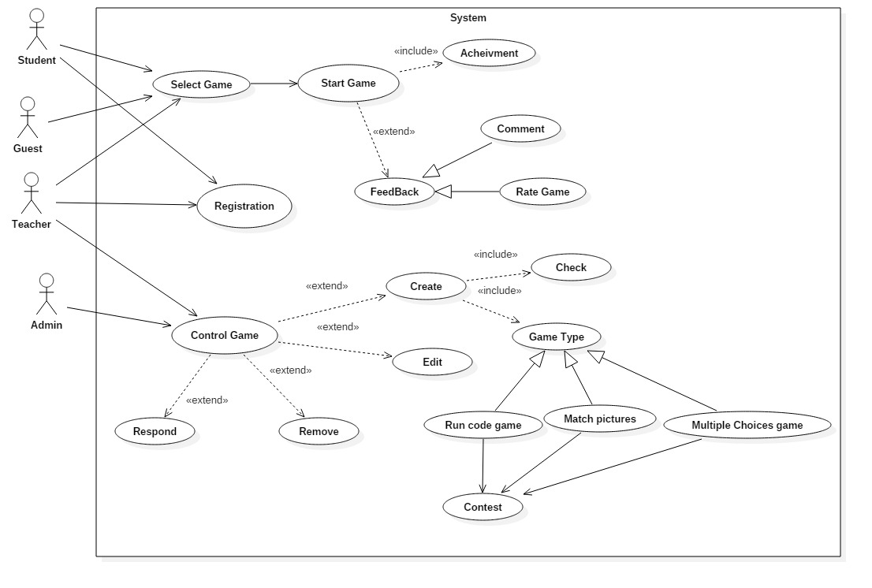

## Use Case Tables

|  |  |  |
| --- | --- | --- |
| Use Case ID: | 1 | |
| Use Case Name: | Select Game | |
| Actors: | Student, Teacher, Guest | |
| Pre-conditions: | if was Guest or have Valid User name and password | |
| Post-conditions: | Game starts Loading | |
| Flow of events: | **User Action** | **System Action** |
| 1- User Enter Username and Password or select as Guest. |  |
|  | 2- System Verify user data |
|  | 3- System show list of Categories |
| 4- User Select category from the list |  |
|  | 5-filter & show Games |
| 6- User Select the Game |  |
| Exceptions: | **User Action** | **System Action** |
| 1- User Enter username and Password. |  |
|  | 2-System offer to user if Enter Valid User name if user forget password |
|  | 3- user name is invalid and unreadable or incorrect. |
|  | 4-system offer to User to Sign up or Enter as a Guest. |
| Notes and Issues: | Performance is good in searching in data base. | |

|  |  |  |
| --- | --- | --- |
| Use Case ID: | 2 | |
| Use Case Name: | Start Game | |
| Actors: | Student, Teacher and Guest. | |
| Pre-conditions: | Must login or Enter as a guest and select game. | |
| Post-conditions: | Update achievement | |
| Flow of events: | **User Action** | **System Action** |
|  | 1-System Load Game. |
|  | 2-System search in user data about the Last Level |
|  | 3- system offer hints to user about Game if it’s the first Time |
| 4-play Game |  |
|  | 5-system calculate the score of level |
|  | 6-system offer Feedback |
| Exceptions: | **User Action** | **System Action** |
| 1-User Close Game |  |
|  | 2-System Call Achievement |
| 3-User Not Finish Level |  |
|  | 4-System Call Achievement with not Finish |
|  | 5-System record the Score and Show |
| Includes: | Achievement | |
| Extends | Feed Back | |
| Notes and Issues: | If user is Guest not call Achievement and Feed Back | |

|  |  |  |
| --- | --- | --- |
| Use Case ID: | 3 | |
| Use Case Name: | Achievement | |
| Actors: | Student, Teacher | |
| Pre-conditions: | Must login or Enter as a guest | |
| Post-conditions: | Update user Achievement in Database | |
| Flow of events: | **User Action** | **System Action** |
| 1-user Finish the Level. |  |
|  | 2- System get the Score of level |
|  | 3- System Update User Achievement |
|  | 4-Show User Achievement |
| Exceptions: | **User Action** | **System Action** |
| 1- user not Finish the Level |  |
|  | 2- system restart the Level |
| Notes and Issues: | User can restart the Level if want more Achievement points | |

|  |  |  |
| --- | --- | --- |
| Use Case ID: | 4 | |
| Use Case Name: | Feedback | |
| Actors: | Student, Teacher | |
| Pre-conditions: | Must User have Valid Account | |
| Post-conditions: | Update user Feedback | |
| Flow of events: | **User Action** | **System Action** |
|  | 1-Show Game’s comments and Game Rate |
|  | 2-system call Comment |
|  | 3- System Call Rate Game |
| 4-User Enter his Feedback (“Comment or Rate”) |  |
|  |  | 5-system offer to user if he wants edit or remove comment |
| Exceptions: | **User Action** | **System Action** |
| 1- user not Finish the Level |  |
|  | 2- system restart the Level |

|  |  |  |
| --- | --- | --- |
| Use Case ID: | 5 | |
| Use Case Name: | Rate | |
| Actors: | Student, Teacher | |
| Pre-conditions: | Must login | |
| Post-conditions: | Record user rate in database. | |
| Flow of events: | **User Action** | **System Action** |
|  | 1-show rate box for user to enter his rate |
| 2-User Enter his rate |  |
|  | 3-Record user rate in database |
|  | 4-Update the average rate of this game |
| Exceptions: | **User Action** | **System Action** |
| 1-User doesn’t enter his rate. |  |

|  |  |  |
| --- | --- | --- |
| Use Case ID: | 6 | |
| Use Case Name: | Comment | |
| Actors: | Student, Teacher | |
| Pre-conditions: | Must login | |
| Post-conditions: | Record user comment in database. | |
| Flow of events: | **User Action** | **System Action** |
|  | 1-show comment textbox for user to write his comment |
| 2-User Enter his comment |  |
|  | 3-Record user comment in database |
|  | 4-Update the average comment of this game |
| Exceptions: | **User Action** | **System Action** |
| 1-User doesn’t enter his comment |  |

|  |  |  |
| --- | --- | --- |
| Use Case ID: | 7 | |
| Use Case Name: | Registration | |
| Actors: | Student, Teacher | |
| Pre-conditions: | Must not be a machine | |
| Post-conditions: | Record user data in database. | |
| Flow of events: | **User Action** | **System Action** |
|  | 1-Ask user to Enter requirement data. |
| 2-User Enter requirement data. |  |
|  | 3- system check Valid Username and E-mail |
|  | 4- system Record User Data in Database |
| Exceptions: | **User Action** | **System Action** |
| 1- User Enter requirement data. |  |
|  | 2- username is invalid and unreadable, E-mail are used or unreadable, valid password |
|  | 3-System offer to user to Edit invalid requirement. |
| Notes and Issues: | Must user Enter Valid Requirement Data | |

|  |  |  |
| --- | --- | --- |
| Use Case ID: | 8 | |
| Use Case Name: | Game Control | |
| Actors: | Admin, Teacher | |
| Pre-conditions: | Log in as Admin or as Teacher | |
| Post-conditions: | Update control Game Data in Database. | |
| Flow of events: | User Action | System Action |
|  | 1-show list of Function |
| 2-User Select one function |  |
|  | 3- system call this Function |
|  | 4- system Update Control Game Data in Database |
| Exceptions: | User Action | System Action |
| 1- User Select one function. |  |
|  | 2- system check if it available function |
|  |  | 3-system show message “that not available function” |
| Extends | Create, Remove, Edit, Respond | |

|  |  |  |
| --- | --- | --- |
| Use Case ID: | 9 | |
| Use Case Name: | Create | |
| Actors: | Admin, Teacher, Game | |
| Pre-conditions: | Log in as Admin or as Teacher and Select Create Function | |
| Post-conditions: | Update Data in Database. | |
| Flow of events: | User Action | System Action |
|  | 1-show list of Category |
| 2-User Select One Category |  |
|  | 3- show List of Game Types |
| 4- User Select one of Game type |  |
|  | 5-system call Game Type |
|  | 6-System Sent Game to Admin |
| Exceptions: | User Action | System Action |
| 1- user Create Game |  |
|  | 2- system check if Admin reject this Game |
|  | 3-system show why admin reject this game |
| Include: | Game Type | |
| Check | |
| Notes and Issues: | Admin doesn’t need Approve to Create Game | |

|  |  |  |
| --- | --- | --- |
| Use Case ID: | 10 | |
| Use Case Name: | Remove | |
| Actors: | Admin, Teacher | |
| Pre-conditions: | Log in as Admin or as Teacher and Select Remove Function | |
| Post-conditions: | Remove Game in Database. | |
| Flow of events: | User Action | System Action |
|  | 1-show list of Games that he Created |
| 2-User Select Game that he wants to remove |  |
|  | 3- system show box if he sure to remove |
| 4- User Press Okay |  |
|  | 5-system Remove Game from Database. |
| Exceptions: | User Action | System Action |
| 1- user press No |  |
|  | 2- system back to Select another function |

|  |  |  |
| --- | --- | --- |
| Use Case ID: | 11 | |
| Use Case Name: | Edit | |
| Actors: | Admin, Teacher | |
| Pre-conditions: | Log in as Admin or as Teacher and Select Edit Function | |
| Post-conditions: | Edit Game in Database. | |
| Flow of events: | User Action | System Action |
|  | 1-show list of Games that he Created |
| 2-User Select Game that he wants to Edit |  |
|  | 3- show Game Data |
| 4- User make some Edit to Data |  |
| 5-User save his Edit |  |
|  | 6-System Sent Game After Edit to Admin |
| Exceptions: | User Action | System Action |
| 1- user Edit Game |  |
|  | 2- system check if Admin reject this edit |
|  |  | 3-system show why admin reject this edit |
| Notes and Issues: | Admin doesn’t need Approve to Edit Game | |

|  |  |  |
| --- | --- | --- |
| Use Case ID: | 12 | |
| Use Case Name: | Respond | |
| Actors: | Admin, Teacher | |
| Pre-conditions: | Log in as Admin or as Teacher and Select Respond Function | |
| Post-conditions: | Respond Save in Database. | |
| Flow of events: | User Action | System Action |
|  | 1-show list of Games |
| 2-User Select Game that he wants to show Comments |  |
|  | 3- show Game Comments |
| 4- User Can make Respond |  |
|  | 5-system Record this Respond |
| Exceptions: | User Action | System Action |
| 1- User Select Game that he wants to show Comments |  |
|  | 2-system show message “You can’t Respond to this Game” |
| Notes and Issues: | Admin have full access to Respond to any Game | |

|  |  |  |
| --- | --- | --- |
| Use Case ID: | 13 | |
| Use Case Name: | Game Type | |
| Actors: | Teacher, Admin | |
| Pre-conditions: | Log in as Admin or as Teacher. | |
| Post-conditions: | Show template of the game to the user. | |
| Flow of events: | **User Action** | **System Action** |
|  | 1-System show game types. |
| 2-user select game type. |  |
|  | 3-system show game type template. |
| 4- user select game Template |  |
| 5- user Enter his Data according to template. |  |
|  | 6- system show contest template |
| 7- user select contest template to create his game |  |
| 8- user Enter his Data according to template. |  |
|  | 9- Save this Game to Teacher Data |
| Notes and Issues: | This Use Case Have 3 Use Cases in Generalization Relation | |

|  |  |  |
| --- | --- | --- |
| Use Case ID: | 14 | |
| Use Case Name: | Check | |
| Actors: | Admin | |
| Pre-conditions: | Must Log in as Admin | |
| Post-conditions: | Publish Game. | |
| Flow of events: | **User Action** | **System Action** |
|  | 1-system show list of Category |
| 2-Admin select one category. |  |
|  | 3- system show the Game types |
| 4- Admin select Game type |  |
|  | 5- system show list of un approve Games |
| 6- Admin select one Game |  |
| 7- Approve the Game |  |
|  | 8-System Publish Game |
| Exceptions: | **User Action** | **System Action** |
| 1-Admin Hasn’t Approve the Game |  |
|  | 2- system show box to make a comment |
| 3- Admin write his comment about why not Approve |  |

# Ownership Report

|  |  |
| --- | --- |
| **Item** | **Owners** |
| Function and nonfunction Requirement | *Roaya and Emam* |
| Use cases Requirement | *Ehab and Sameh* |
| Other | *All of them team* |